# Logging on to remote access – ALT

1. Log on with your EXT credential to get a WHSCT desktop
2. Launch Microsoft Edge
3. Browse to <https://belctxstorpool01.hscni.net/>
4. If this fails, try again, entering the https:// address. It may say your connection isn’t private. Click ADVANCED and continue to site:  
   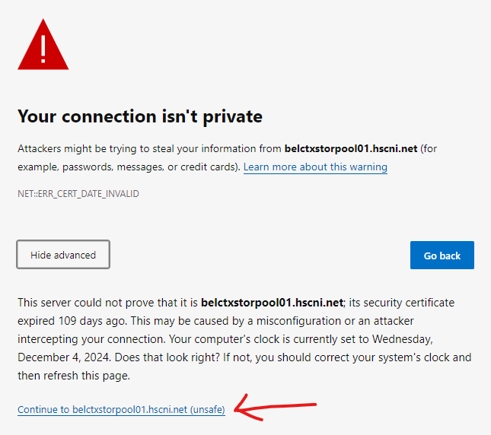  
   It’s grand – don’t worry.
5. You will then need to sign in. Use your FULL EMAIL ADDRESS and Windows password (BHSCT). The Domain should change from WESTERN TRUST to belfasttrust.hscni.net  
   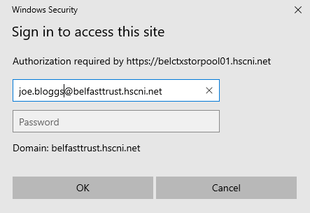
6. If you get this error:  
   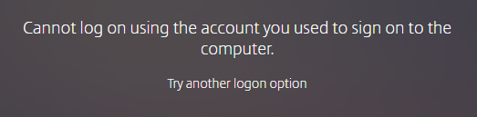  
   you need to **refresh the page** and click “Log On”. If it persists, you may need to delete cookies, but this should be OK.
7. You should now have your Citrix apps displayed:  
   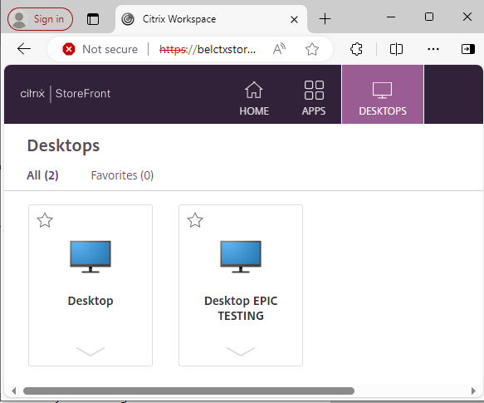
8. Launch “Desktop” to pull up a Belfast Trust desktop. If it says “User name or password is incorrect”, just hit OK; you will be presented with what superficially looks like a normal BHSCT login window.  
   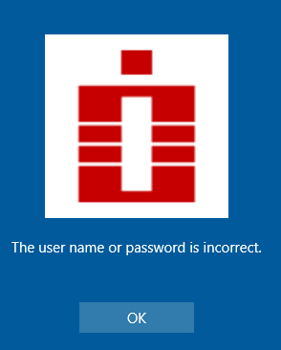
9. However your login may fail - the reason this happens is it’s trying to log you into this computer, not the network! When you try to log in you may see “**Enter credentials for BELCTXSBCE076 (This computer)**” or some such nonsense. Instead select “**BELFASTTRUST**” and use your username and password as usual..
10. It will go away and think about it for a while – the spinning wheel of death – but eventually your virtual desktop will appear. WHEW!

# STARLIMS in the remote environment

Right – that was almost too easy, wasn’t it?

To start StarLIMS you will have a problem – your Citrix login will be out of sync. Here’s how to get that working.

1. Start Citrix Workspace  
   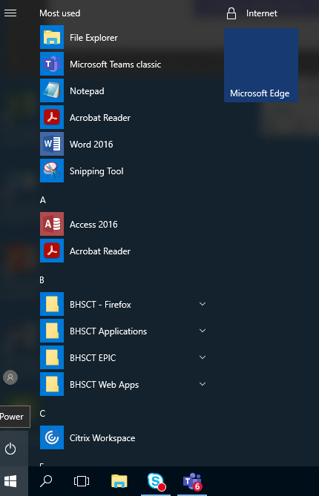
2. If you try to launch StarLIMS you